**SHS Flexsim Competition Progress Report**

|  |
| --- |
| Jackie Lu, Sam Pertsas, Nicolette Somers, Peng Ying-Chih |
| Industrial and Systems Engineering, The University of Florida, Gainesville, FL 32611, USA |
| E-Mail: jackielu.contact@gmail.com |

1. **Introduction**

The Society for Health Systems Flexsim competition features a case study involving a pre-made model of a hospital’s Operating Room. Surgical operations featured in this model come with complexities in patient conditions, facility planning, number of support staff, policies & practices, and more. The objective of this case study is to identify variables that could improve the model and recommend the most effective configuration of the Operating Room; which is up to our definition of efficient. In addition to the provided simulation, an excel sheet containing information on Surgeons, distribution times, earnings, and more is provided to help with our assessment. Utilizing a simulation here is very appropriate because it involves manipulating variables and experimenting with various scenarios with uncertain outcomes in a complex process.

1. **Assumptions**

Assuming that procedures prioritizes surgeons from top to bottom based on the excel sheet.

Assuming that the OR room opens at 6:00, while the hospital hours open at 5:30.

1. **Input Data**

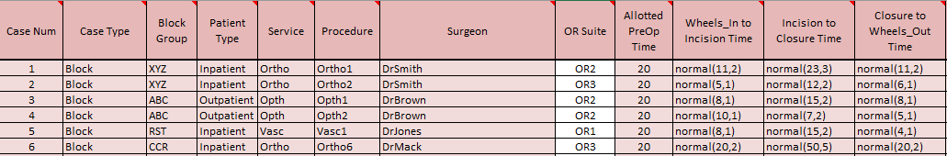

Figure 1: Distribution data provided in the excel sheet

The provided excel sheet provides expected distribution times on certain processes and the Surgeon who is performing it. All items in red can not be modified for the project, however items in white (OR suite) can be modified.

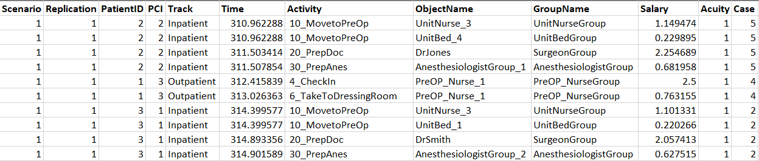

Figure 2: Example of data from the Experiment feature

When testing for scenarios with different variables such the count of scrub nurses, the Experiment feature can provide statistics based on what is told to the Data Collector. Above is tracking the usage of staff including their salary and how many cases they were part of. This is just an example of what can be tracked during variable testing.

1. **Conceptual Modeling Logic**

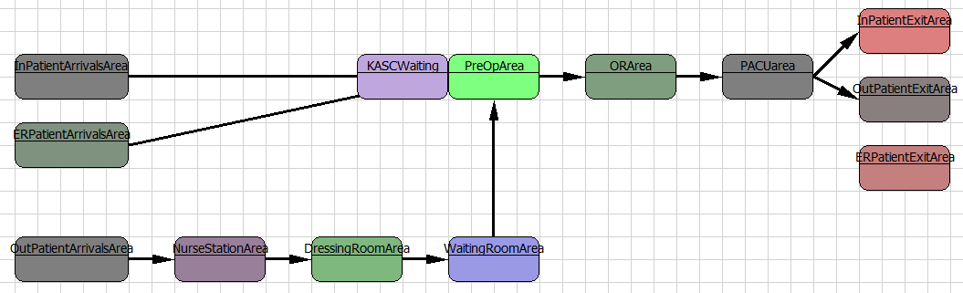

Figure 3: Flowchart logic of simulation

The modeling logic above demonstrates the paths for InPatients, OutPatients, and EmergencyPatients. Patients will go to the waiting area, pre operation, operating rooms, post anesthesia care unit, and then leave the process.

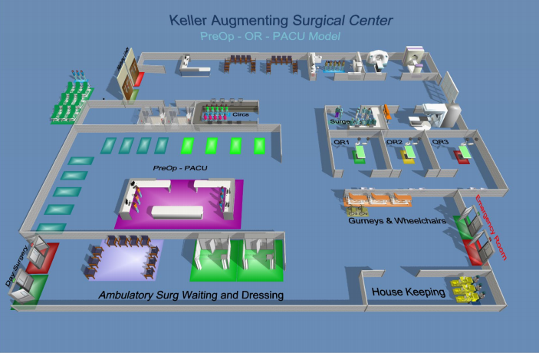

Figure 4: 3D Model representation of the OR

Visual model helps others understand the process and identify the significance of some elements such as distance, waiting areas, and more.

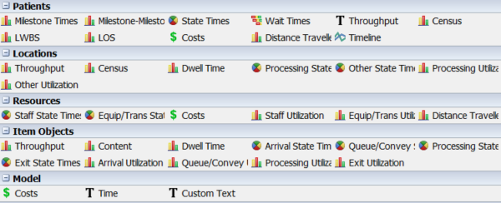

Figure 5: Elements to be analyzed in recommendation

Various elements are to be assessed in the optimization of the Operating Room. Of the many items, the team will prioritize profit, staff utilization, OR utilization, patient wait times, and minimizing Left Without Being Seen (LWBS).